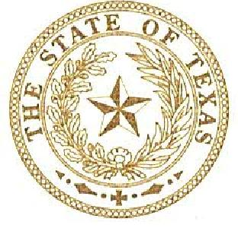
TONY DALE
STATE REPRESENTATIVE
DISTRICT 136
January 5, 2017
Mr. Ian Benouis
Cedar Park, TX 78613
Dear Mr. Benouis,
Thank you for your correspondence relating to the medical marijuana. As your State Representative, I appreciate hearing your concerns.
As you are likely aware, marijuana is categorized by federal law as a schedule I drug under the Controlled Substances Act (CSA). As such, the federal government states that marijuana "has a high potential for abuse, has no currently accepted medical use in treatment in the United States and there is a lack of accepted safety for use of the drug or other substance under medical supervision."
The U.S. Food and Drug Administration regulates controlled substances, such as marijuana and medical pharmaceuticals. Since the laws governing these drugs are federal laws, the state of Texas is obligated to follow federal law. Article VI, Clause 2 of the United States Constitution is referred to as the "Supremacy Clause." Under the Supremacy Clause federal laws made pursuant to the Constitution are the supreme laws of the land and states are bound to follow those laws. Furthermore, in any conflict between federal and state law, the federal law must be applied.
The Constitution and federal law bind the State of Texas and other states. Additionally, the State of Texas does not have any state agency or state-contracted private entity that tests the efficacy of drugs, conducts peer-reviewed studies and/or medical experiments to determine the safe dosage of any drug.
I am aware that other states have changed their laws regarding medical or recreational use of marijuana. They have done so in violation of federal law. It is my assessment that Texas also violated federal law when it passed a law last session regarding low-THC cannabis for certain medical uses.
As recently as August 11, 2016, the U.S. Drug Enforcement Administration (DEA) denied petitions to reschedule marijuana under the Controlled Substances Act (CSA). In response to the petitions, the DEA requested a scientific and medical evaluation and scheduling recommendation from the Department of Health and Human Services (HHS), which was conducted by the U.S. Food and Drug Administration (FDA) in consultation with the National Institute on Drug Abuse (NIDA). Based on the legal standards in the CSA, marijuana remains a schedule I controlled substance because it does not meet the criteria for currently accepted medical use in treatment in the United States, there is a lack of accepted safety for its use under medical supervision, and it has a high potential for abuse.

It is important to recognize that state marijuana laws do not change the fact that using marijuana continues to be an offense under federal law. State laws do not change the criteria or process for FDA approval of safe and effective medications.
Furthermore, in 2015 Governor Abbott made his views on this issue clear. He said, "I remain convinced that Texas should not legalize marijuana, nor should Texas open the door for conventional marijuana to be used for medical purposes." He was also quoted as saying, "As Governor, I will not allow it."
Since marijuana is a drug under federal jurisdiction I encourage you to contact your United States Member of Congress and U.S. Senators with your concerns. For your convenience, I have attached their contact information below.

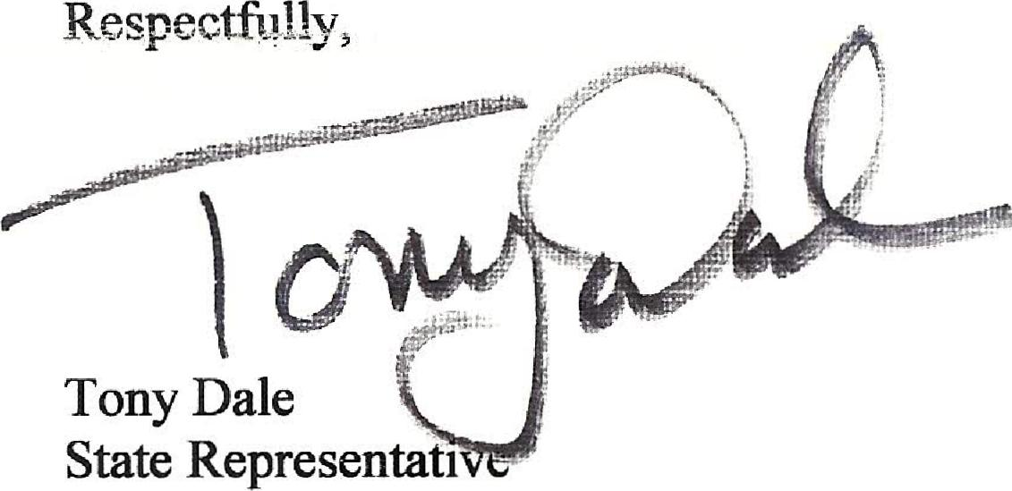
Respectfully,
Tony Dale
Congressman John Carter Washington, D.C. Office 409 C.H.O.B.  Washington, D.C. 20515 Phone: (202) 225-3864 | Senator John Cornyn  Washington, D.C. Office:  517 Hart Senate Office Building, Washington D.C. 20510-4302 Phone: (202) 224-2934 | Senator Ted Cruz  United States Senate  B4OB Dirksen Senate Office Building Washington, D.C. 20510-4306  Phone: (202) 224-5922

